Date: October 6, 2016
To: Planning Board
From: Jennifer Burney, Director of Planning & Land Use
Re: Economic Development
Economic Development Advisory Committee (EDAC) – Created by the Board of Selectmen
Economic Development creates opportunities for jobs, housing, transportation, and the quality of life for community members. The 2009 Master Plan identifies the creation of an Economic Development Committee (EDC) as a goal. Serving in this capacity the Economic Development Advisory Committee (EDAC) will reach out to businesses, non- profits, at risk properties, Hansom, Mass Port and other stakeholders to understand future expansion plans, issues, concerns or constraints and create relationships early on. Having an EDAC will create a platform that will allow collaboration, shared expertise and mentorship opportunities between the business and non-profit community.
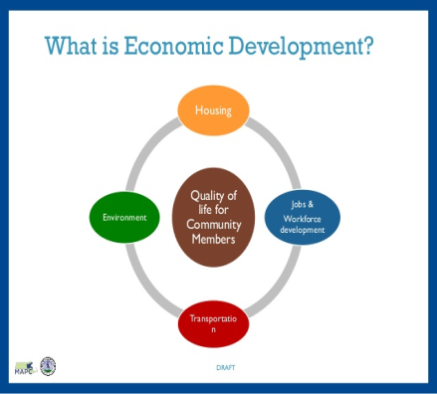
The EDAC can also provide information to the business community regarding state, regional, and local resources such as job training, technical assistance, initiatives, funding and grants opportunities. The EDAC can coordinate trainings, mitigate barriers and bring awareness and attention to the value and quality of the businesses and non-profits in Lincoln and develop opportunities to connect, feature, and highlight these businesses through events, campaigns, and social media such as development of a webpage. The EDAC will survey the existing and vacant space in Lincoln and seek opportunities to support filling vacant spaces with businesses that add to the quality of local residential life by providing goods, services and amenities desired by residents, jobs and livelihoods for Lincoln residents, and tax revenue that support the town services that are important to Lincoln residents.
I recommend that an Economic Development Committee entitled “Economic Development Advisory Committee”(EDAC) be established by the Board of Selectmen with a maximum of 7 members and 2 non-ex-officio members, for a 3 three year term. Initially, the terms should be staggered with 2 one year terms, 2 two year terms and three year terms. Creating an EDC is not authorized by state statute but by the Town’s own processes for creating a commission and their mission and functions/responsibilities.
- 1-Board of Selectmen or designee
- 1-Planning Board member or designee
- 1-Non-Profit*(e.g. National Park, Mass Audubon, Farm, Cultural/Historical Organization)
- 1- Rural Land Foundation or designee
- 2 Local business owners
- 1 Member at large with experience in retail, realtor, developer, business development etc...
- 2 ex-officio (non-voting) members: Planning Director (or staff) and Town Administrator

Draft Mission Statement
To help attract, retain and grow businesses (for profit and non-profits) and jobs in Lincoln that respects Lincoln’s character and adds to the quality of local residential life by providing goods, services and amenities desired by residents, jobs and livelihoods for Lincoln residents, and tax revenue that support the town services that are important to Lincoln residents.
Charge:
The Economic Development Advisory Committee (EDAC) appointed by the Board of Selectmen, serves in an advisory capacity and leadership role to provide recommendations about areas that impact all aspects of Economic Development. Key to EDAC efforts is to work closely with the Town’s leadership and residents to retain and attract businesses and grow business and jobs in Lincoln that respects Lincoln’s character and adds to the quality of local residential life by providing goods, services and amenities desired by residents, jobs and livelihoods for Lincoln residents, and tax revenue that support the town services that are important to Lincoln residents.
- Work closely with the Board of Selectmen, Planning Board and South Lincoln Planning Implementation Committee as well as other groups and organizations in Lincoln, region and state.
- Act as a liaison between government (local & state).
- Meet with the Board of Selectmen at a minimum bi-annual basis to give updates.
- Reach out to nonprofits, businesses, public sector, agricultural farms, at risk properties, Hansom, Mass Port and other stakeholders to understand future expansion plans, issues, concerns or constraints.
- Survey existing and vacant space in Lincoln available and seek opportunities to support filling vacant spaces with businesses that add to the quality of local residential life by providing goods, services and amenities desired by residents, jobs and livelihoods for Lincoln residents, and tax revenue that support the town services that are important to Lincoln resident.
- Identify and assess Lincoln’s economic development opportunities and advise the Board of Selectmen, Planning Board, and South Lincoln Planning Sub Committee and other town boards about economic development policy & planning opportunities e.g. agri-tourism, mixed use or commercial projects requiring new zoning, Lincoln Station, At Risk Properties, housing opportunities.
- Attend economic development meetings and conferences.
- Highlight Lincoln’s local businesses, non-profits and natural resources by bringing awareness and attention to the value and quality of the businesses and non-profits in Lincoln through events, campaigns, and social media such as development of a website.
- Share resources with the business community regarding technical assistance, expertise, grants, incentives, opportunities, mentorship, and job training that may be available through local, state and federal initiatives.
- Create networking opportunities for collaboration for mentorship between businesses, not-for profits etc., public sector and residents.
- Create/Maintain an economic climate that enhances the viability of working lands and conserves natural lands.
- In conjunction with staff explore Grant opportunities and other resources as necessary.
- In conjunction with staff or consultants conduct studies and analysis e.g. Feasibility Study.
- Develop an economic portrait of Lincoln’s primary industry and small business sectors including nonprofits by working with consultants and/or economists from some of the local universities e.g. Dr. Alan Clayton-Matthews and Dr. Barry Bluestone of Northeastern University, and Maureen Dunne of Framingham State University.

Economic Overview:

- In 2015 there were 190 establishments in Lincoln that provided 2,034 jobs with a total of $142,823,259 in wages.
- North Lincoln has vacancy rate of 30-40%
- Lincoln Station:
  - Town’s major commercial center only draws 20% of Lincoln’s residents disposable income
  - Median Household Income of $150,000 and Over 40% earn combined income of 200k or more
  - Residents within one-mile radius of Lincoln Station generate demand of over $40 million in goods & services per year
  - Mall only earns $7.7 million per year in sales & leaks as much as 80% of total consumer spending in adjacent towns
  - Relies on sales & income from Donelan’s which is the anchor
  - Recent departure of AK Bistro and Whistle Stop & well as vacancies across the street

South Lincoln Planning Implementation Committee (SLPIC) – Created by the Planning Board
By investing in the community as well as Lincoln Station and South Lincoln it will create a more vibrant attractive place for residents & visitors to visit spend time and spend money. Lincoln Station is considered the hub of Lincoln with the MBTA Station, adjacent trails, conservation land, farms, Codman Community Farms, Mass Audubon, deCordova Museum, Walden Pond, elementary and middle schools and housing developments such as Lincoln Woods and Ryan Estates.

I recommend that a Planning Board Subcommittee be established entitled “South Lincoln Planning Implementation Committee” (SLPIC). The SLPIC will be a subcommittee of the Planning Board that will focus on project specific planning projects and establish project specific working teams as needed that include additional members representing various stakeholders based on the type of project.
I recommend that the SLPIC consist of 7 members and 1 non-ex-officio member.
- 1-Planning Board member
- 1-Board of Selectmen member
- 1-RLF member
- 1-Business owner (other than RLF)
- 1-Housing Commission Member
- 2 Members at Large with experience in retail, realtor, developer, business development etc...
- 1 ex-officio (non-voting members): Planning Director or staff
Charge:
- Explore grants and other resources for projects for jobs, housing, transportation, and the quality of life for community members.
- Explore grants for infrastructure funding such as road, parking, parking garages, train stations, sidewalks, street scape, parks, playgrounds, recreation facilities, brownfields, water, and waste water.
- Conduct studies and analysis as needed: Feasibility Study, Traffic Studies etc.
Project specific working teams may be established at the discretion of the SLPIC for specific projects and can include additional members representing various stakeholders based on the type of project.

- Redevelopment of DPW
- MBTA improvements
- Signage
- Wayfinding & Placemaking
- Parking & Infrastructure
- Zoning

- Housing
- Beautification & Signage (plantings, trees)
- Marketing
- Business improvement district and/or Store Improvement Program

Collaboration between Planning and Selectman, EDAC, SLPIC & Project Specific Teams

Implementation: Grants, Programs & Initiatives

Conway School
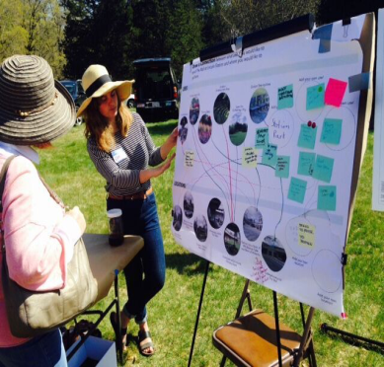
From April through June 2016 staff from the Lincoln Planning & Land Use and Conservation Departments, and staff and members of the Rural Land Foundation worked as an Advisory Group with the Conway School, a landscape and environmental design graduate school to create a vibrant, walkable town center that would spur consumer spending within South Lincoln.

They were charged with the following:

- Enhance visual cohesiveness;
- Improve pedestrian & multimodal connections;
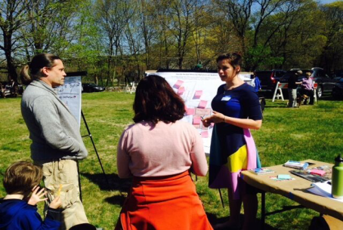
- Look at ways to complement Complete Street’s application to enhance pedestrian & bicyclist safety; and
- Benefit all residents of Lincoln but particularly adjacent residential developments such as Ryan Estates an over 55 development and Lincoln Woods a mixed income rental development with 70 units affordable units.

The Conway School conducted a Community Needs Assessment:
On April 30, 2016 the Conway Team participated in the Community Fair

“Conducted an on-line survey (residents, businesses & adjacent housing developments participated)
- Created 3 concept designs Click to View Report

Commonwealth Places
Placemaking aims to improve the quality of public places and the lives of communities. Design and economic development are key to placemaking. The most significant component is the community process and programming that can facilitate social interaction and engagement. Placemaking has been used to revitalize commercial districts using small, community-driven investments that leverage economic growth and development.
MassDevelopment, in conjunction with its consultant, Patronicity, has developed a new program called “Commonwealth Places” a creative funding mechanism to advance community placemaking projects statewide. This program began in Michigan with 81 projects and close to a $5,000,000 investment.
Crowdfunding is a tool to fund projects for public space improvements and allows the public to support initiatives and instills a community pride as residents become invested in their surroundings.
This program is a 50-50 match with up to $50,000 for crowdfunding donations to support placemaking projects. The goal is to raise funds within 60 days of approval of a project. Projects must be ready to proceed within six months of reaching the projects crowdfunding goal and be complete within 18 months. The Planning Board (The Town) would like to partner with the Rural Land Foundation to apply for this grant with the RLF as the applicant. For more information please visit: https://www.patronicity.com/commonwealthplaces. On behalf of the Planning Board the Planning Department recently applied for this grant and is awaiting approval.
Department of Housing and Community Development (DHCD) – Downtown Initiative
Retail Consulting Services
A $10,000 technical assistance grant is provided by DHCD to provide retail consulting services for best retail practices to existing businesses in Lincoln. The objective for the program is to assist local retail and storefront businesses to learn and apply current best practices which will lead to a stronger commercial district that would attract customers and additional quality businesses. The grant is still be finalized and should become available Fall 2016.
http://www.mass.gov/hed/community/funding/massachusetts-downtown-initiative-mdi.html
Wayfinding
Wayfinding encompasses all of the ways in which people orient themselves in physical space and navigate from place to place.

- Create Experiences that Connect People to Places
- Signage
- “You had me at hello” Welcome/Gateway
- Logos/Branding
- Website
- Maps
- Kiosk: multidisciplinary includes digital
- Banners & Awnings
- Business Directories
- Mobile Apps

Examples of Wayfinding grant funded projects:
http://www.mass.gov/hed/docs/dhcd/cd/mdi/2011awards-bolton.pdf
http://www.mass.gov/hed/docs/dhcd/cd/mdi/2014ipswich.pdf
Business Improvement District Feasibility Analysis
Public/private partnership, special tax assessment to fund programs and strategies such as:
- Beautification & Signage (plantings, trees)
- Marketing (farmers market, holiday stroll, special shopping, dining promotions, seasonal events
- Parking & Infrastructure
Example of grant funding project: http://www.mass.gov/hed/docs/dhcd/cd/mdi/2014greatbarrington.pdf
Complete Streets
The Town applied and has been awarded $50,000 for technical assistance that provides $50,000 to help the town develop a prioritization plan. Once this is approved the town can apply for funding of up to $400,000.
Eligible Complete Streets Infrastructure
Traffic & Safety e.g. pavement markings, signage, signals, speed humps, lighting, resurfacing, restriping, intersection reconstruction, traffic calming, roundabouts
Bicycle Facilities e.g. shared use paths improvements, bicycle lanes, bike parking fixtures/shelters, safe drain grates, bike boulevards, wayfinding
Pedestrian Facilities e.g. sidewalk repairs, ADA complaint, wayfinding sidewalks, curb extensions, crosswalks,
Transit facilities – transit shelter, railroad grade crossing improvements, park n ride facilities, crosswalks, pedestrian improvements – crosswalks, ramps, signage.
A public forum is being held on Wednesday, October 19, 2016 at 7:30pm in the Donaldson Room
Visit the Planning Board webpage for updates and more information: http://www.lincolntown.org/index.aspx?NID=776
Other Grant Opportunities
Grants can be explored for projects such as the DPW & Surrounding Area for the possible of a Feasibility Study for redevelopment of DPW into housing/mixed use. Other Competitive grants are for shovel ready projects to create housing and job creation and infrastructure funding such as road, parking garages, train stations, sidewalks, street scape, parks, playgrounds, recreation facilities, brownfields, water, and waste water.

- MAPC DLTA 2017: Funds would be available sometime around December 2016 for use through December 2017.

- Community Compact: May be used to fund projects under the Community Compact during FY2017.

- EOEEA Grants: The Executive Office of Energy and Environmental Affairs has a new bond-funded grant program that will start up in FY2017; portions of the funds available will be able to be used for land-use planning projects.

- Mass Work Grants: Competitive grants for shovel ready projects to create housing and job creation. Supports infrastructure funding such as road, parking garages, train stations, sidewalks, street scape, parks, playgrounds, recreation facilities, brownfields, water, and waste water.

