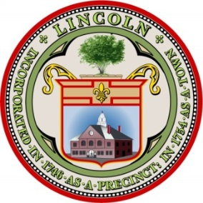
ORIOLE LANDING

Proposed 60-Unit Rental Housing Development

Frequently Asked Questions

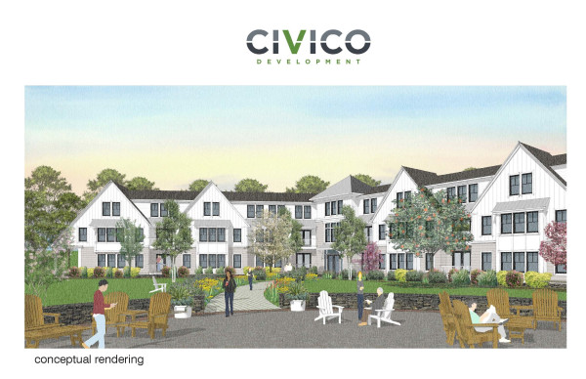
This FAQ document was created by the HOW Group (Housing Options Working Group) to address many of the questions that have been asked about the proposed 60-Unit Rental Housing Development located in Lincoln Ma.
- PROJECT DESCRIPTION
Oriole Landing is a 60-unit mixed-income rental project to be located at 1 Mary’s Way on approximately six acres. As proposed, Oriole Landing will offer the Town of Lincoln a rental housing option including fifteen units (25%) reserved for those earning a maximum of 80% of the Area Median Income. All 60 units will count on the Town’s Subsidized Housing Inventory (SHI).​
- ABOUT CIVICO
Civico Development is a small local company located in Newton Ma. The team is comprised of architects with a commitment to quality design, historic preservation, and neighborhood-oriented infill development. Their work includes projects of all scales, focused on walkability and human scale. All of their projects are LEED Certified. To learn more about Civico and their projects visit their website.

- PROJECT INCEPTION
- HOW Group

At an early 2017 Land Use Chair Quarterly (LUCQ) meeting, members recommended the creation of a committee to identify opportunities to create affordable housing. The Board of Selectmen created the Housing Options Working Group (HOW Group) with representatives from Housing, Planning, the Rural Land Foundation, and the Board of Selectmen. Its first meeting was held on September 14, 2017.
Just around this time the Planning and Land Use Department was contacted by Civico regarding a proposed project located at 1 Mary’s Way. It was suggested that Civico meet with the newly formed HOW Group to discuss the project. Civico met with the HOW Group on October 17, 2017. The HOW Group suggested that Civico meet with Lincoln’s various boards and committees to solicit feedback and to reach out to neighbors, including the Commons.
- TOWN PROCESS

- Can you explain the Planning Board and Town Meeting Process?
Section 12.5 of the Zoning Bylaw provides for the North Lincoln Overlay District which allows for greater flexibility to permit a developer to propose a project at a particular location. Under the Overlay, and pursuant to Section 12.5, a parcel of land may be placed into a North Lincoln Planned Development District by a two-thirds vote at Town Meeting. A Preliminary Development and Use Plan must be presented at the Town Meeting which considers the creation of the North Lincoln Planned Development District and must be identified in the motion to create the district.
Five projects in Lincoln have been approved under this process:
- Battle Road Farms (1986)
- Lincoln North (1986)
- Minuteman Inn (never completed (1989))
- Minuteman Commons (2006)
- Groves/Lincoln Deaconess (2006)
Oriole Landing will be Planned Development District #6.

- What is the North Lincoln Overlay District and Planned Development District?
The North Lincoln Overlay District was created in 1986 by Town Meeting Vote. The North Lincoln Overlay District is a “floating overlay district” that does not appear on a zoning map. A “floating overlay district” is usually not designated on a map like conventional zoning districts such as Lincoln’s business and residential districts. However, an overlay and a conventional district are in some ways similar as they both have development standards. Once enacted by a vote at Town Meeting (Lincoln did this in 1986) the North Lincoln Overlay District floats over the designated area for use WHEN an applicant applies for a Planned Development District.
The North Lincoln Overlay District (floating district) allows for greater flexibility by requiring few predetermined standards. It allows a developer to propose a development and use plan to a particular site.
The developer proposes the creation of a North Lincoln Planned Development District for the development and use of land located in the North Lincoln Overlay District with a specific plan (the Preliminary Development and Use Plan)
The use and dimensional controls are governed by Section 12.5 of the Zoning Bylaw and not the underlying zoning district.
The Planning Board holds a public hearing for the creation of the proposed Planned Development District where the applicant presents the Preliminary Planning and Use Plan.
At Town Meeting, residents will be asked to vote to place the floating North Lincoln Overlay District into a North Lincoln Planned Development District. The Preliminary Development and Use Plan is presented to Town Meeting. The warrant article for the Lincoln Planned Development District will include the Preliminary Use and Development Plan.
Within two years following town meeting, the Planning Board may grant a Special Permit and Site Plan Approval for the development of the land within the North Lincoln Planned Development District.
View the diagram below for a better understanding.

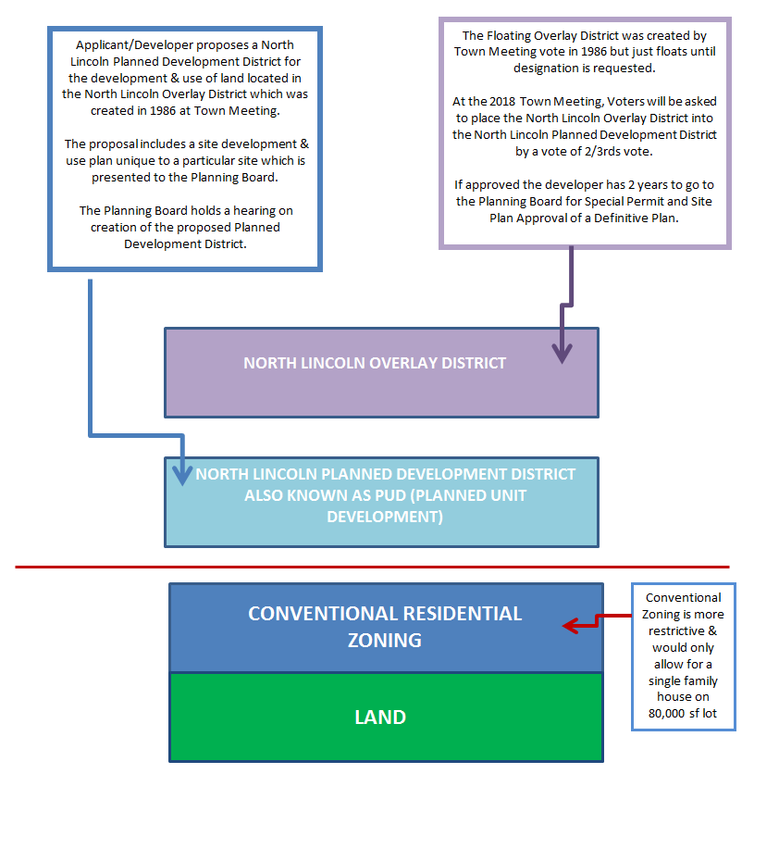
- Planning
Lincoln’s Zoning Section 12.5.4 recommends that the Applicant meet informally with the Planning Board to discuss the project. Civico met with the Planning Board on December 12, 2016. Click here to view the Power Point presentation given to the Planning Board.
The Planning Board is required to hold the public hearing for the zoning amendment to create the North Lincoln Planned Development District and the associated Preliminary Development and Use Plan. The Applicant is required to mail a copy of the plan and hearing notice to all postal patrons in Lincoln at least 14 days prior to the hearing.
The public hearing is scheduled for Tuesday, March 6, 2018 at 7:00pm at Town Hall in the Donaldson Room. Please visit the Town’s website or Click here to view the application and materials
- Town Meeting
At the March 24, 2018 Town Meeting, Lincoln Voters will be asked to approve a Bylaw Amendment to establish North Lincoln Planning Development District #6 with an identified Preliminary Development and Use Plan. Click here to view the draft Warrant Article.
A 2/3rds vote is required.
If the warrant article is passed, Civico must return to the Planning Board within two years for a public hearing for a Special Permit and Site Plan Approval of a Definitive Development and Use Plan.​
Any substantial change to the Preliminary Development and Use Plan following Town Meeting will require a 2/3rd vote of Town Meeting. .
- Historic
Under Lincoln’s General Bylaws Article XXI, Civico is required to go before the Lincoln Historical Commission for the demolition of existing structures to determine if they are historically or architecturally significant. Civico is working with the Historical Commission to develop a plan that will honor a historic house located on the property.
- PROJECT IMPACTS

- What types of studies are required?
The applicant is required to submit a site plan, traffic study, municipal impact analysis, traffic analysis and an environmental analysis. All submitted studies are available on the Town’s website or by clicking here.
The application and materials are also submitted to the Board of Selectmen, Conservation Commission, Board of Health, Town Engineer and Police and Fire who will provide comments to the Planning Board.
- What is the density of other projects in Lincoln?
Total Units counted on SHI
Development Acres Total Units Units/Acre
The Commons | 30.967 (3.647 acres was taken by Mass DOT for the Route 2 Reconstruction) | 259 (168 independent living units, 40 assisted living units, 25 memory care units, 25 nursing care units, 1 original house to property | 11.95 | 30
Oriole Landing | 5.98 | 60 | 10.5 | 60
Minuteman Commons | 3.67 | 32 | 8.72 | 8
Lincoln Woods | 19.89 | 125 | 6.28 | 125
Battleroad Farm | 24.1 | 120 | 4.98 | 48
Green Ridge | 4.53 | 22 | 4.86 | 1
Ryan Estates | 7.95 | 24 | 3.02 | 0

- Parking

According to the Lincoln Zoning Bylaw Section 15, 1 parking space is required for each dwelling unit and sufficient parking space for employees or visitors.

The applicant is proposing a total of 103 parking spaces. 60 parking spaces will be provided under the 2 buildings for residents and an additional 43 outdoor parking spaces will be available for residents, visitors, and any employees.

- Will traffic increase?

A traffic study has been completed and submitted as part of Civico’s application. Click here to view. The Town is in the process of having the traffic study reviewed by a third party consultant.

- Proposed Amenities and Connection to the Community
The proposed project will have a common house available for community gatherings, meetings and social events, as well as a fitness gym. The property will include a community garden, indoor bicycle parking and a common green space. These amenities are a vehicle to foster a sense of community. The developer has also met with the Council on Aging to discuss partnering for community social services.
Civico is exploring shuttle services for residents to local markets and public transportation as well as connecting to nearby open space and trails. This project will seek LEED certification.
- School Impact

Civico submitted a Fiscal Impact Analysis which reports that 9-16 school age children are expected and likely to be spread over various grades. Since the developer is proposing only 1 and 2 bedroom units, the impact is expected to be the lower figure.

- Can the development ever be expanded or changed to condominiums?

Any changes to the development including unit increases or tenure (rental to condos) would require Town Meeting approval.

Expansion is unlikely because the developer is keeping the bedroom count under 90 bedrooms in order to use a septic system. Bedroom counts over 90 require the construction of a package treatment plant at a cost of approximately $1,000,000 and annual maintenance of approximately $60,000.
- Is this a Citizen’s Petition or a Committee sponsorship?
A petitioner can seek a citizen’s petition by obtaining the signatures of 10 registered Lincoln Voters. In this case, the Housing Trust and Housing Commission are co-sponsoring the Warrant Article.
In the past the Board of Selectmen was the sponsor of the Groves/Lincoln Deaconess project.
- What will happen to the existing cell tower on site?
The current owner will maintain ownership of the tower and continue its lease with Verizon. Civico will provide an access easement to the tower.
- PUBLIC ENGAGEMENT
There are a number of ways for the public to learn more about the project and/or ask questions.
- TOWN WEBSITE - Development Projects and Initiatives: http://www.lincolntown.org/973/Oriole-Landing-Housing-Development

- LINCOLN HOUSING COALITION
​​The Housing Coalition and Civico hosted a public forum on January 31, 2018.
​
​Visit the Housing Commission's webpage to learn more about the project and affordable housing:
​
​​​Housing Commission Webpage and Housing Commission Oriole Landing Overview
- CIVICO
Civico hosted a neighborhood meeting on January 18 and a community Open House on January 25 at the Library.​
​
Schedule of Civico Open Houses
​Civico will be hosting more Community Open Houses at the Library and Senior Center. The dates are as follows:
- February 6, Tuesday 2:30 pm Council on Aging
- ​February 8, Thursday 6:30-8:30pm Library
- ​February 15, Thursday 1-3 pm Library
- ​February 22, Thursday 6:30-8:30 pm Library
- March 16, Friday 1:00 pm Council on Aging
​
Other dates may be added. Check the Oriole Landing website for meeting updates.
​
​Online Oriole Landing coUrbanize Platform: https://courbanize.com/projects/oriolelanding/ and Oriole Landing Facebook
- HOUSING
- What will units rent for?

The following rents are estimates. The Department of Housing and Community Development (DHCD) sets the affordable rental price based on 80% Area Median Income. Market rents are based on Civico’s research. 15 of the 60 units will be affordable.

Unit Type Bedrooms/Baths Area Market Rent Affordable Rent
1 Bedroom | 1/1 | 644-811 sf | $2,200 | $1,564
1+ Bedroom | 1/1 | 823-881 sf | $2,400 | $1,564
2 Bedroom | 2/2 | 913-1054 sf | $2,600 | $1,759
2+ Bedroom | 2/2 | 1014-1142 sf | $2,900 | $1,759

- Is there local preference for the affordable units?

It is expected DHCD will allow up to 70% of the affordable units (10 of the 15 affordable units) to be rented to households qualified as local preference

- Residents of the Town of Lincoln
- Employees of the Town of Lincoln
- Employees of local businesses
- Families with children enrolled in Lincoln Public Schools.

- Will the affordable units be protected in perpetuity?

The Regulatory Agreement will require that the units continue to meet the criteria for inclusion on the Subsidized Housing Inventory (SHI). However, most financial products for Affordable Housing have deed restrictions that expire. The Affordable Housing Trust will loan Civico $1,000,000 subject to a note in mortgage to ensure that the units remain on the SHI permanently. In the event, any of the units are no longer considered affordable; the loan must be paid back.

- If Lincoln needs less than 60 units to safely reach the 10% affordable housing for 2020 why do we need a project this size?

- A project such as the one Civico is proposing is needed for a variety of reasons:

- Lincoln needs approximately 10 units of affordable housing to meet SHI requirements for 2020. The Housing Coalition projects that the Town will need 10 units of affordable housing per decade just to keep pace with development trends. To learn more about the SHI visit http://www.lincolntown.org/DocumentCenter/View/35191

- Aging Population: This project is not just about the SHI. Another goal of the 2014 Housing Plan is to create diverse rental housing for seniors, handicapped individuals, young professionals and families. This rental project would fulfill a need for empty nesters and seniors looking to downsize. The data gathered by the US Census Bureau indicates the number of seniors over age 65 will double from 2010 to 2030.

2010
Source: American Survey Data

- Long Housing Waiting Lists: Currently Lincoln has limited rentals available and many have long waiting lists.

Lincoln Woods located in the Lincoln Station area is a 125 mixed-income rental community. Lincoln Woods current waiting list for affordable and market rate units is as follows:
- 1 Bedroom Units: 63
- 2 Bedroom Units: 36
- 3 Bedroom Units: 18

- Controlling Development: One of the goals identified in the 2014 Housing Plan is:

“To preserve the character of the town, Lincoln must maintain 10% affordable housing”.

Controlling development is the key in maintaining Lincoln’s small town character, open space, conservation trails and farming. If Lincoln cannot maintain a SHI above 10% then Lincoln is vulnerable to 40B developers. Lincoln would lose local control of determining density, height, quantity and tenure of the units and instead would be placed in the control of the 40B developer.

- How many people have signed up for the affordable housing accessory apartment program?

The Affordable Accessory Apartment By-law was approved at the 2017 Town Meeting. Another warrant article was passed granting a tax exemption on the portion of the property used for affordable housing. The Housing Commission is waiting for the state legislature to approve the tax exemption for Affordable Accessory Apartments. Once approval is received, the Housing Commission will hold a lottery to attract households eligible for affordable housing. This lottery will create a waiting list of eligible households seeking to rent apartments in Lincoln.

- What is the status of the potential affordable housing on Lewis Street?

Sadly the owner, Mr. McCart recently passed away. His children have asked the ZBA for an extension to their Special Permit. However, it is unclear when or if any affordable units will be created at this property...

- 2014 HOUSING PLAN GOALS

- Housing Choice
The 2014 Housing Plan states: Lincoln needs to expand its affordable housing portfolio to accommodate seniors, handicapped persons, low and moderate-income families, and people with incomes up to 150% of Area Median Income (AMI).
The Oriole Landing project adds to the Town’s diversity of housing options.

- Local Control
The 2014 Housing Plan 2nd Goal states: “To maintain control over housing development by retaining a minimum of 10% affordable housing”.

Oriole Landing will sustain Lincoln’s Subsidized Housing Inventory over the 10% mandate for the next 30 years. Since 25% of the units (15 units) will be affordable, DHCD will add all 60 units to Lincoln’s Subsidized Housing Inventory. This State policy encourages the production of mixed-income rental housing as it is more affordable by definition than ownership housing. Lincoln has retained local control over housing development by strategically providing affordable housing.

- Aging Population

The 2014 Housing Plan states that 39% of Lincoln’s residents are over the age of 55. The over 65 population is the fastest growing cohort throughout the country as the baby boomers (born between 1945 and 1965) are now over 50 years old. By 2030, seniors over the age of 65 will have doubled from 2010 (1,073 in 2010 and 2,173 in 2030).

Lincoln seniors who are not in need of affordable housing can downsize to a condominium. Others can age in place. Lincoln has three age-restricted developments:

- Minuteman Commons (32 condominiums)
- Ryan Estates (24 condominiums); and
- The Commons (30 rental units, 100 ownership, 38 cottages, 40 units of assisted living & 50 nursing & memory care units)

Of the 264 age-restricted units in Lincoln, only 16 (eight condos at Minuteman Commons and eight rental units at The Commons) are affordable for seniors whose income is at 80% or less of Area Median Income (AMI).

Oriole Landing will offer another option for Seniors.

- MAPC Housing Projections

According to the Metropolitan Area Planning Council (MAPC) robust economic growth depends on the region’s ability to attract and retain more people, especially young adults to fill the positions vacated by retiring Baby Boomers and provide a well-educated labor force.

MAPC projection for housing development:

- Householders (born after 1980) will be more inclined toward urban living than their predecessors, and less likely to seek out single family homes; and

- An increasing share of senior-headed households will choose to downsize from single-family homes to apartments or condominiums.
MAPC concludes that as the population ages, the demand for large single family home ownership will decrease while the demand for condominiums, small houses and rental units will grow. To meet this demand, 48% to 60% of all new housing units in Massachusetts should be multi-family housing such as condominiums and rental housing.

- 40B COMPLIANCE

- The 2000 decennial United States census determined that Lincoln’s affordable housing stock of 181 units did not meet the 10 percent statutory minimum required by M.G.L. Chapter 40B.

- To address this housing deficit and to plan for the 2010 census, the Housing Commission used the 2003 Consolidated Housing Plan as a strategic action plan and called for the production of between 40 and 60 units.

- Using the 2003 Housing Plan, Lincoln added 56 units to its inventory, a substantial growth in its affordable housing program. This growth could not have been achieved without the establishment of two significant organizations, the Community Preservation Committee in 2003, which recommends to Town Meeting the awarding of Community Preservation Act (CPA) funds, and the Affordable Housing Trust in 2006. CPA funds infused the affordable housing program with the money to create 20 units of housing:

  - 3 units at Sunnyside Lane
  - 2 units at Minuteman Commons
  - 1 unit at Greenridge
  - 14 units in three group homes
  - 36 units were created without financial support from the Town; instead, they were created through zoning and Town Meeting approval (30 units at The Commons--originally named The Groves--and six units at Minuteman Commons).

- At the time of the 2010 Census, Lincoln’s Subsidized Housing Inventory reached 236 units (10.96%)

- Since 2010, Lincoln has added only 2 units of affordable units and has determined that Lincoln SHI will fall below 10% to 9.66%. This is a deficit of 9 units of affordable housing.

Oriole Landing will add 60 units of affordable housing to Lincoln’s SHI and will work to keep Lincoln over the 10% mandate for the next three decades. Oriole Landing with give Lincoln the autonomy to select housing developments that will preserve Lincoln’s rural small town character, with conservation trails, open space and agriculture.
- What is the Subsidized Housing Inventory and what is the process for getting units to count. ?
The Subsidized Housing Inventory is a list of qualified affordable housing, certified by the Department of Housing and Community Development (DHCD). Lincoln currently has 238 units of affordable housing on their Subsidized Housing Inventory.
The Chapter 40B requirements, under the Local Action Program, to add units to the Subsidized Housing Inventory are:
- Regulatory Agreement/Deed Restriction: A deed restriction recorded at the registry of deeds. For this project, the deed restriction is contained within the Regulatory Agreement. The Agreement is between three parties: The Town of Lincoln; the Department of Housing and Community Development; and the Developer.

The Regulatory Agreement specifies how many units must be affordable, at what price, size and the eligibility requirements to occupy a unit.

- Local Action: The Local Action Program does not require a 40B Comprehensive Permit; instead “the units must be built pursuant to a local action such as zoning provision, a condition of a variance or special permit issued by the planning board or zoning board of appeals…”

- Affirmative Fair Marketing Plan: For units to be eligible for the Subsidized Housing Inventory DHCD must approve an Affirmative Fair Marketing Plan and Resident Selection Plan.

A requirement for new developments is a lottery to populate the units by eligible households. The lottery process usually starts four to six months prior to the expected occupancy. After the lottery, units are occupied through a waiting list.

